**Experiment 2.4**

**Student Name: Gaurav Kumar                                     UID: 22MCC20177**

**Branch: CC-DEVOPS Section/Group : 1/B**

**Semester: 1                                                                    Date of Performance: 04/12/2022**

**Subject Name : Python Programming                         Subject Code: 22CAH645**

1. **Write a program in python to read sort a list of integer elements using the bubble sort method. Display the sorted element on the screen.**

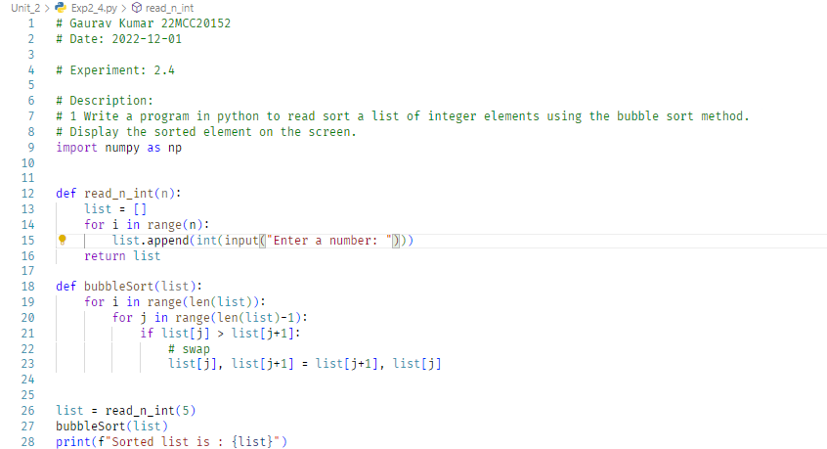

**Output (screenshots):**

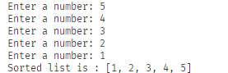

1. **Write a program in python to find out the frequency of each element in a list using a dictionary.**

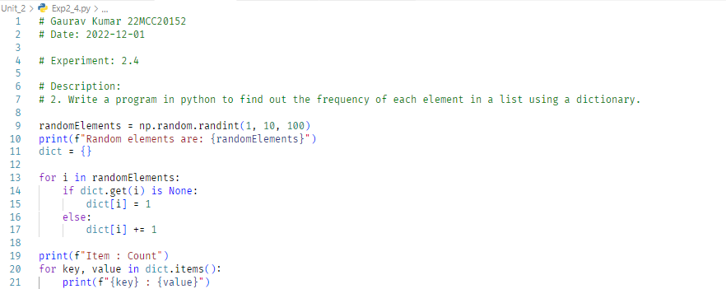

**Output (screenshots):**

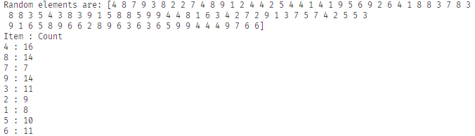

**4) Learning outcomes (What I have learnt): Times new roman 12 size**

**1. Learn about Bubble Sort**

**2. Learn about Dictionary**

**3. Learn about list**

**Evaluation Grid:**

|  |  |  |  |
| --- | --- | --- | --- |
| Sr. No. | Parameters | Marks Obtained | Maximum Marks |
| 1. | Demonstration and Performance  (Quiz) |  | 22 |
| 2. | Worksheet |  | 8 |